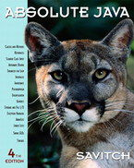 COSC 1320
Name: _________________ Terminal #__

Estimated Hours 1
Actual Hours

TA (Textual Analysis) for UML USE CASE Diagram MODEL
Programming Assignment 2:
(20 points.)
(due date found in the COSC 1320 BB Calendar!)
You must use Microsoft WORD program. Insert the TEMPLATEs for Actors and Use Cases in this Requirements Document.

Please have Step 1, 2, 3, and 4 in this order.
Requirements Analysis: Construct UML USE CASE Diagram MODEL

GUI PIZZA APPLICATION SWING

Write a GUI application program, to create a menu for a pizza shop. Use check boxes, radio buttons, and a JButton to allow a customer to make selections and process their order. Use a text area to display the customer’s order and the amount due. A sample menu and a customer’s order is shown in Figure below:

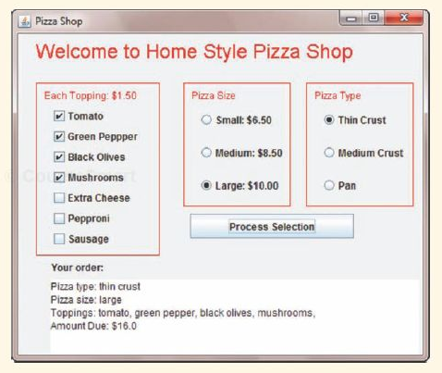

PLEASE DO NOT INCLUDE THESE PAGES AS YOUR DELIVERABLES! This is just for your use. Please have Step 1, then 2, etc. order in your deliverables.

UML LANGUAGE THAT MUST BE USED FOR TEXTUAL ANALYSIS!!!

UML USE CASE DIAGRAM MODELING:

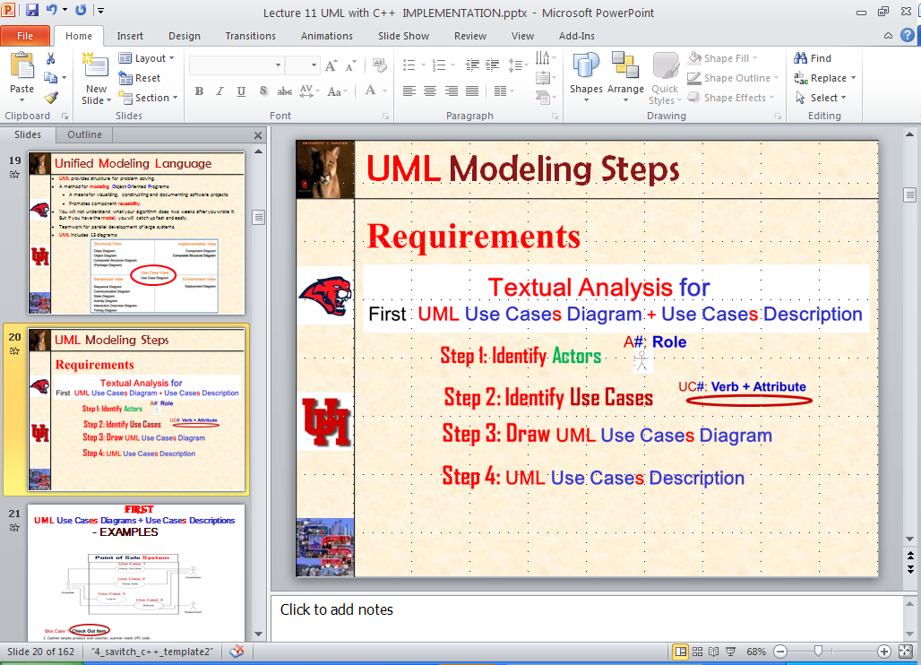

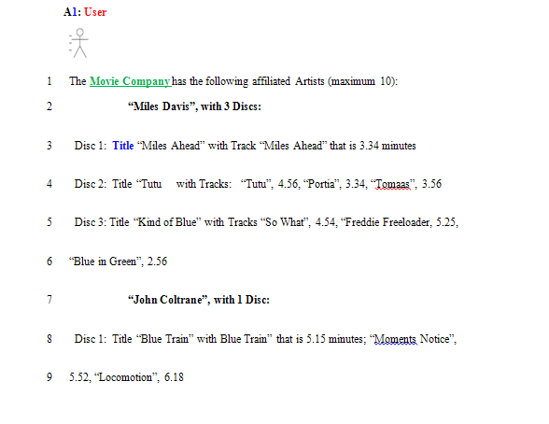

SEMANTICS: Actor #: Label
# is replaced by 1, 2,.
Label is a (first letter Upper Case) Role.

UML LANGUAGE:

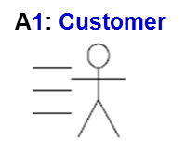 Number is 1 and Label is Customer (Upper Case C)
TEMPLATE:
A1: Customer
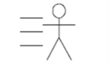

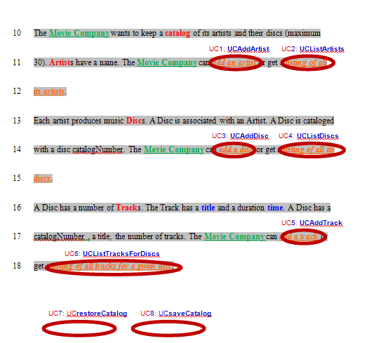

SEMANTICS: UC #: Label
# is replaced by 1, 2,.
Label is a (first letter Upper Case) Action Verb + Descriptive Attribute.



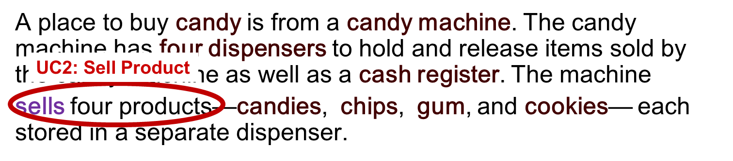
TEMPLATE:
UC#: Verb + Attribute

